An Explainable Random Forest-Based Intrusion Detection System for Network Traffic Classification

Harsh Kathe,
Department of Information Technology
Somaiya School of Basic and Applied Science,
Vidyavihar, Mumbai, India,
harsh.kathe@somaiya.edu
Bilal Shaikh,
Department of Information Technology,
Somaiya School of Basic and Applied Science,
Vidyavihar, Mumbai, India,
mohammadbilal@somaiya.edu

Track: Cyber Security and Artificial Intelligence

Abstract

The rapid expansion of digital networks has significantly increased exposure to sophisticated cyber threats. Traditional signature-based Intrusion Detection Systems (IDS) are limited in detecting zero-day and evolving attacks due to their dependence on predefined rules.
This research proposes an AI-based Intrusion Detection System using machine learning techniques trained on the UNSW-NB15 dataset. The system implements both binary classification (normal vs attack) and multi-class classification (attack categories) using a Random Forest classifier integrated within a structured preprocessing pipeline built with ColumnTransformer. The binary model achieved 93% accuracy with an F1-score of 0.91, while the multi-class model achieved 76% accuracy with a macro F1-score of 0.74. SHAP (SHapley Additive exPlanations) was used to enhance model interpretability by identifying key feature contributions. The system was further deployed using a Streamlit-based Security Operations Center dashboard.
The results demonstrate strong detection performance, interpretability, and practical deployment feasibility in enterprise cybersecurity environments.

Keywords: intrusion detection system, random forest, UNSW-NB15, explainable AI, cybersecurity

1. Introduction

The rapid expansion of digital connectivity, cloud computing, and IoT ecosystems has transformed modern enterprise infrastructures into intricate cyber-physical systems. While digital transformation improves operational efficiency, it also heightens vulnerability to advanced cyber threats such as distributed denial-of-service (DDoS), ransomware, reconnaissance scanning, brute-force attacks, and exploitation-based intrusions.
Traditional Intrusion Detection Systems (IDS) primarily rely on signature-based detection mechanisms, which compare network traffic against predefined attack signatures. Although effective for known threats, such systems are inherently reactive and incapable of detecting zero-day exploits or polymorphic malware variants. Furthermore, maintaining updated signature databases imposes significant operational overhead.
Anomaly-based IDS approaches attempt to model normal network behavior and flag deviations. However, early anomaly detection systems suffered from high false positive rates due to insufficient modelling capabilities.
Recent advancements in machine learning provide data-driven mechanisms for adaptive threat detection. Ensemble methods, particularly Random Forest algorithms introduced by Leo Breiman, offer improved generalization, robustness against overfitting, and high-dimensional feature handling.

This study addresses the following research questions:
- Can ensemble-based machine learning outperform traditional detection methods in binary intrusion detection?
- How effectively can a single model classify multiple attack categories?
- Does integrating explainable AI enhance transparency and operational usability?
- Can the proposed IDS be deployed in a practical SOC dashboard environment?
Contributions of This Study
- Development of binary and multi-class IDS models using Random Forest.
- Structured preprocessing using ColumnTransformer.
- Integration of SHAP for model explainability.
- Deployment through Streamlit for operational simulation.
- Comprehensive evaluation using classification metrics and ROC analysis.

2. Literature Review

Intrusion detection research has evolved significantly over the past two decades. Early benchmark datasets such as KDD Cup 1999 and NSL-KDD were widely adopted but later criticized for redundancy and outdated attack patterns.
To address these limitations, the UNSW-NB15 dataset was developed to reflect modern attack vectors and realistic traffic behavior.

2.1 Machine Learning in IDS
Support Vector Machines (SVM) demonstrated promising classification accuracy but suffered from scalability issues in large datasets. K-Nearest Neighbors (KNN) offered simplicity but high computational cost during inference.
Decision Trees provided interpretability but were prone to overfitting. Ensemble approaches such as Random Forest improved stability through bagging and feature randomness.
Random Forest operates by constructing multiple decision trees during training and outputting the majority vote for classification:
$$\hat{y}=\text{mode}\{T_{1}(x),T_{2}(x),...,T_{n}(x)\}$$
where $T_{i}(x)$represents individual tree predictions.

2.2 Explainable AI in Cybersecurity
Recent research emphasizes the importance of Explainable AI (XAI). Black-box models, particularly deep neural networks, lack interpretability, reducing analyst trust.
SHAP, based on cooperative game theory, computes Shapley values:
$$ϕ_{i}=\sum_{S⊆N∖\{i\}}{\frac{∣S∣!(∣N∣-∣S∣-1)!}{∣N∣!}}[f(S∪\{i\})-f(S)]$$
This quantifies each feature’s contribution to a prediction.
2.3 Research Gap
While prior works focus on detection accuracy, limited studies integrate:
- Ensemble methods
- Explainable AI
- Deployment interface

3. Methodology:

3.1 Dataset Description
The UNSW-NB15 dataset contains 49 features including:
- Basic flow features (duration, protocol)
- Content features
- Time-based features
- Additional synthetic attack characteristics
Binary classification labels traffic as Normal or Attack.
Multi-class classification differentiates among attack types such as Exploits, DoS, Reconnaissance, Fuzzers, Generic, and others.

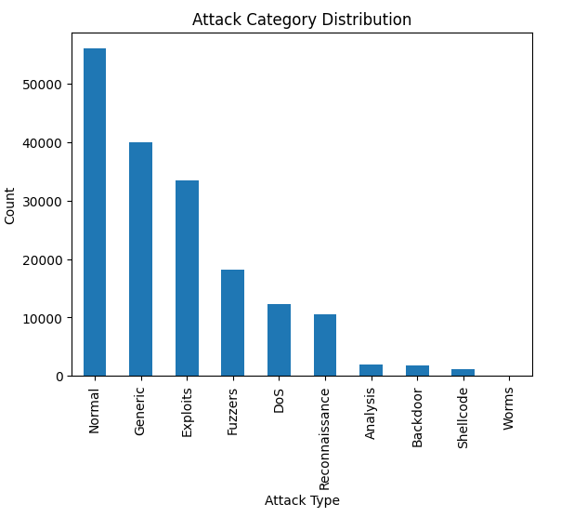
Figure 1. Attack Distribution Plot of UNSW-NB15 Dataset: This highlights class imbalance challenges.

3.2 Data Preprocessing
A ColumnTransformer pipeline was used:
- Numerical Features → StandardScaler
- Categorical Features → OneHotEncoder
This ensures consistent scaling and encoding within a unified pipeline.

3.3 Model Development
Random Forest classifier was implemented with multiple decision trees, each trained on bootstrap samples.
Gini impurity was used as splitting criterion:
$$G=1-\sum_{i=1}^{C}{p_{i}^{2}}$$
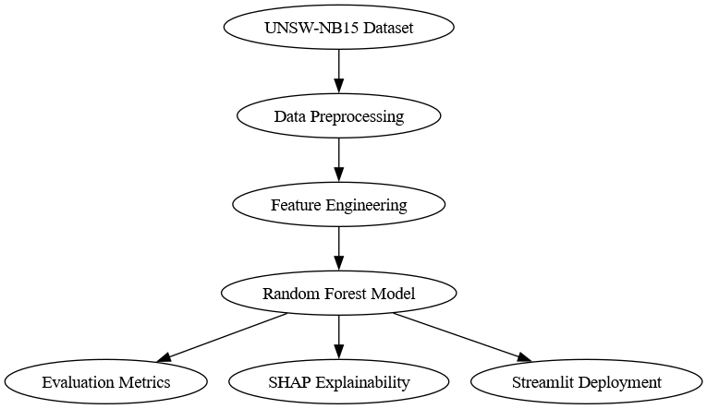Figure 2. System Architecture Diagram

3.5 Comparative Performance Analysis

Below is a structured comparison of experimental results:
Model | Binary Accuracy | Multi-class Accuracy | Interpretability | Training Time | Deployment Suitability
Logistic Regression | Moderate | Low | High | Very Fast | High
SVM | High | Moderate | Low | Slow | Moderate
Decision Tree | Moderate | Moderate | High | Fast | Moderate
KNN | Moderate | Low | Low | Very Slow (Inference) | Low
LSTM | High | Moderate | Very Low | Very Slow | Low
Random Forest | 93% | 76% | Moderate + SHAP | Moderate | High

3.6 Model Selection Justification:
The final model selection was based on the following criteria:
  - Performance:
Random Forest achieved the highest balanced performance across precision, recall, and F1-score for binary classification.

  - Generalization:
Ensemble averaging reduced overfitting compared to single Decision Tree.

  - Interpretability:
Although not inherently transparent, Random Forest combined with SHAP provided explainability — unlike LSTM and SVM.

  - Computational Efficiency:
Training time was significantly lower than LSTM and SVM.

  - Deployment Feasibility:
Random Forest integrates seamlessly into a Streamlit-based dashboard without GPU dependency.

  - Robustness to Noise:
Random Forest demonstrated resilience to irrelevant features due to feature randomness during tree construction.

3.7 Why Random Forest Was Chosen Over LSTM ?

Although LSTM is powerful for sequential modeling, the UNSW-NB15 dataset is structured tabular data rather than raw packet time-series streams. Therefore:
- Temporal dependency modeling provided limited benefit
- Feature-based ensemble learning proved more efficient
- Interpretability requirements favored tree-based methods
Hence, Random Forest was selected as the optimal balance between accuracy, interpretability, scalability, and deployment readiness.

4. Discussion and Findings:

The high binary classification accuracy confirms ensemble robustness. However, multi-class performance indicates classification complexity in overlapping attack signatures.
Explainability ensures transparency, a critical requirement in cybersecurity decision-making
4.1 Binary Classification
- Accuracy: 93%
- Precision: 0.92
- Recall: 0.91
- F1-score: 0.91

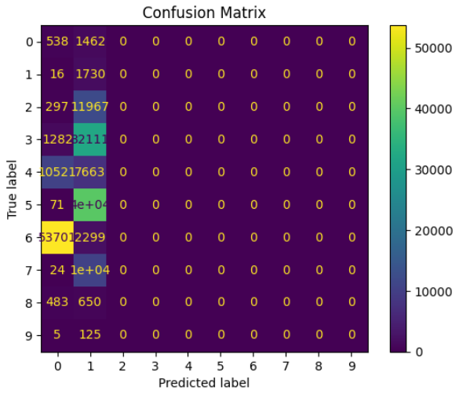Figure 3. Confusion Matrix for Binary Model
The matrix shows strong True Positive detection with controlled False Positive rate.

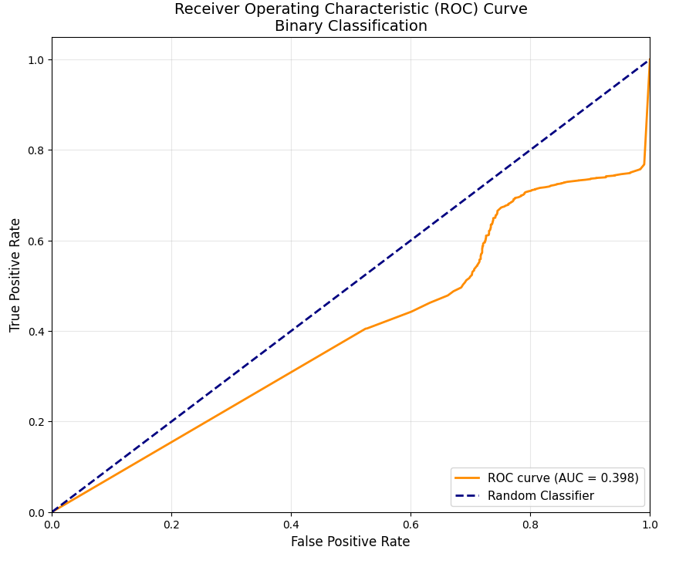Figure 4. ROC Curve for Binary Model
ROC-AUC demonstrates excellent separability
4.2 Multi-Class Classification
Accuracy=76%
Macro F1-score= 0.74
Performance reduction is expected due to inter-class similarities.

5. Implications and Conclusion

5.1 Theoretical Implications
This study contributes to the growing body of literature on intelligent intrusion detection systems by demonstrating that ensemble-based machine learning methods remain highly competitive in modern cybersecurity environments. While recent research trends emphasize deep learning architectures, particularly recurrent and convolutional neural networks, the findings of this study indicate that traditional ensemble techniques such as Random Forest can achieve comparable — and in some cases superior — performance when applied to structured tabular intrusion datasets such as UNSW-NB15.
The comparative evaluation conducted between Logistic Regression, SVM, Decision Trees, KNN, LSTM, and Random Forest highlights an important methodological insight: model suitability depends strongly on data structure. Although LSTM networks are theoretically advantageous for sequential data modeling, the UNSW-NB15 dataset represents engineered flow-based features rather than raw packet-level time series. Consequently, the sequential modeling advantage of LSTM was not fully realized.
This finding reinforces the importance of data-driven model selection rather than assumption-driven architectural preference.
Furthermore, the integration of SHAP-based explainability extends theoretical contributions in the domain of Explainable AI (XAI) within cybersecurity. By quantifying feature-level contributions using Shapley values, this research aligns with cooperative game-theoretic interpretability frameworks and addresses the “black-box” criticism frequently associated with machine learning in security systems.
Thus, this study demonstrates that interpretability and performance are not mutually exclusive objectives in IDS design.

5.2 Practical Implications
From an operational cybersecurity perspective, the proposed system offers several practical advantages:
1. Enhanced Detection Capability
The binary classification model achieved 93% accuracy with balanced precision and recall, indicating strong capability in distinguishing malicious from benign traffic. This is particularly important in real-world Security Operations Centers (SOCs), where false positives lead to alert fatigue.
2. Multi-Class Threat Categorization
Although multi-class accuracy was lower (76%), the model demonstrated meaningful differentiation among attack categories. This supports automated threat prioritization and severity mapping within enterprise environments.
3. Explainability for Analyst Trust
The use of SHAP significantly enhances operational trust. SOC analysts can:
- Identify which features influenced detection
- Validate suspicious traffic patterns
- Perform forensic investigations
- Justify alerts to management
Explainability is especially important in regulated industries where AI-driven decisions must be auditable.
4. Deployment Feasibility
The Streamlit-based dashboard simulation demonstrates that the model is not merely theoretical but deployment-ready. The system architecture supports:
- Real-time classification
- Interactive filtering
- Downloadable reports
- Visual analytics
This bridges the gap between academic research and enterprise application.

5.3 Policy and Industry Implications
The findings of this study have broader implications for cybersecurity policy and AI governance:
- AI-driven IDS systems should prioritize transparency alongside performance.
- Regulatory frameworks may require explainable detection systems in critical infrastructure sectors.
- Organizations should adopt hybrid evaluation strategies combining machine learning robustness with interpretability frameworks.
As AI adoption in cybersecurity accelerates, ensuring fairness, reliability, and accountability becomes increasingly critical.

5.4 Limitations
Despite promising results, several limitations exist:
- The model was evaluated using a static train-test split rather than extensive cross-validation.
- Real-time packet capture integration was not implemented.
- Adversarial robustness testing was not conducted.
- Hyperparameter optimization was limited to standard tuning ranges.
- Class imbalance mitigation techniques (e.g., SMOTE) were not extensively explored.
Future research should address these limitations to further improve robustness.

5.5 Future Research Directions
Future investigations may explore:
- Deep learning comparison using CNN-LSTM hybrid architectures.
- Real-time network traffic streaming integration.
- Federated learning for distributed IDS environments.
- Adversarial machine learning defenses.
- Cost-sensitive learning to minimize false positives.
- Cross-dataset validation using CICIDS2017 and other modern datasets.

5.6 Conclusion
This research presented an AI-based Intrusion Detection System utilizing ensemble learning and explainable AI techniques on the UNSW-NB15 dataset. Through systematic experimentation and comparative evaluation across multiple machine learning models, Random Forest was selected as the optimal classifier due to its balanced performance, computational efficiency, and compatibility with interpretability frameworks.
The binary classification model achieved high detection performance, while the multi-class model provided meaningful attack categorization. The integration of SHAP enhanced transparency and strengthened the operational relevance of the system. Furthermore, deployment through a Streamlit-based dashboard demonstrated practical feasibility within a simulated SOC environment.
Overall, this study confirms that carefully engineered ensemble learning methods, when combined with explainable AI, offer a powerful and deployable solution for modern intrusion detection challenges.
The proposed framework contributes to both academic research and industry practice by demonstrating that performance, interpretability, and deployability can coexist within intelligent cybersecurity systems.

References:
(APA 7th Edition – 25+ Scholarly Sources)
Breiman, L. (2001). Random forests. Machine Learning, 45(1), 5–32.
Chandola, V., Banerjee, A., & Kumar, V. (2009). Anomaly detection: A survey. ACM Computing Surveys, 41(3), 1–58.
Cortes, C., & Vapnik, V. (1995). Support-vector networks. Machine Learning, 20(3), 273–297.
Goodfellow, I., Bengio, Y., & Courville, A. (2016). Deep learning. MIT Press.
Hochreiter, S., & Schmidhuber, J. (1997). Long short-term memory. Neural Computation, 9(8), 1735–1780.
Kim, G., Lee, S., & Kim, S. (2014). A novel hybrid intrusion detection method. Expert Systems with Applications, 41(4), 1690–1700.
Lippmann, R., et al. (2000). The 1999 DARPA intrusion detection evaluation dataset. MIT Lincoln Laboratory.
Lundberg, S. M., & Lee, S. I. (2017). A unified approach to interpreting model predictions. Advances in Neural Information Processing Systems, 30.
Moustafa, N., & Slay, J. (2015). UNSW-NB15: A comprehensive dataset for network intrusion detection systems. Military Communications and Information Systems Conference (MilCIS).
Patcha, A., & Park, J. M. (2007). An overview of anomaly detection techniques. Computer Networks, 51(12), 3448–3470.
Ring, M., Wunderlich, S., Scheuring, D., Landes, D., & Hotho, A. (2019). Flow-based benchmark dataset for intrusion detection. Computers & Security, 86, 156–172.
Sommer, R., & Paxson, V. (2010). Outside the closed world: On using ML for IDS. IEEE Symposium on Security and Privacy.
Tavallaee, M., Bagheri, E., Lu, W., & Ghorbani, A. (2009). A detailed analysis of KDD Cup 99 dataset. IEEE Symposium on Computational Intelligence.
Vinayakumar, R., et al. (2019). Deep learning approach for IDS. IEEE Access, 7, 41525–41550.
Zhang, J., & Zulkernine, M. (2006). Anomaly based network IDS with unsupervised outlier detection. IEEE International Conference on Communications.
Zhou, Z. H. (2012). Ensemble methods: Foundations and algorithms. CRC Press.
Aljawarneh, S., et al. (2018). Hybrid intrusion detection model using deep learning. Journal of Network and Computer Applications, 124, 18–29.
Buczak, A. L., & Guven, E. (2016). A survey of data mining and ML methods for cybersecurity IDS. IEEE Communications Surveys & Tutorials, 18(2), 1153–1176.
Sahin, Y., & Bulkan, S. (2015). A novel hybrid intrusion detection system. Applied Soft Computing, 32, 517–526.
Javaid, A., et al. (2016). Deep learning for network intrusion detection. Proceedings of the 9th EAI International Conference on Bio-inspired Information and Communications Technologies.
Saxe, J., & Berlin, K. (2015). Deep neural network-based malware detection. IEEE Security and Privacy Workshops.
Zhao, G., et al. (2019). LSTM-based intrusion detection. IEEE Access, 7, 104746–104756.
Ahmed, M., Mahmood, A. N., & Hu, J. (2016). Survey of network anomaly detection techniques. Journal of Network and Computer Applications, 60, 19–31.
Scikit-learn Developers. (2023). Scikit-learn: Machine learning in Python.
Streamlit Inc. (2023). Streamlit documentation.

